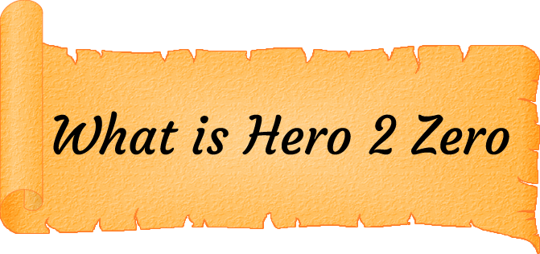

Hero 2 Zero is a digital board game with a fusion of RPG elements and anti-goals. Unlike most games, you start as a hero and your target is to lose your fame and become a regular villager again. As you travel the land you’ll be offered chances to lower or raise your fame levels from fighting and losing to monsters to plain old leaving little Billy in the well he fell in. Silly Billy.

Hero 2 Zero is not a game about climbing your way to the top and beating everyone else, it’s about standing at the top and falling as far as you can. Being a hero is not all it’s cracked up to be you know.

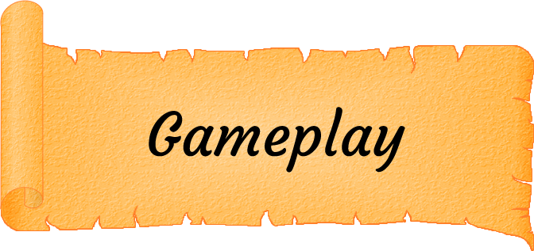

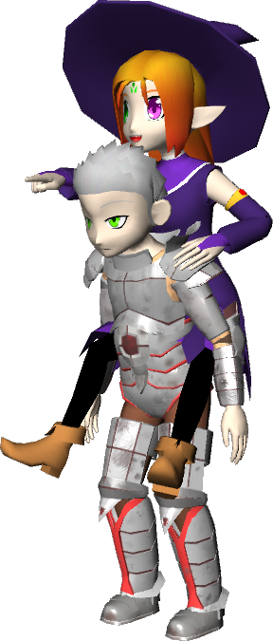

Hero 2 Zero is a turn based board game where each player will adventure around the board with the ultimate goal of dropping their fame and losing their hero status. Players will roll the dice to continue their adventure and choose different directions as the paths start to split; you choose whether or not you enter the forest or climb the mountains.

Players will land on tiles which can do one of a few things. The player could draw an event card based on the tile area, start a battle with a monster, open a chest or just rest plain and simple. Even the best heroes need a rest every now and again.

It is with a combination of these different events that the player will aim to drop their fame before the other players and become the first hero to lose their status.

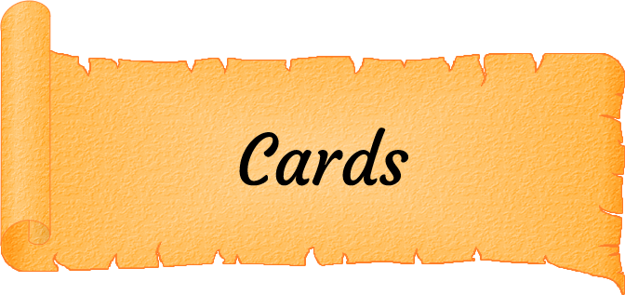

Landing on a card tile will allow the player to draw a card which could have any number of affects from simply lowering a player’s fame to granting them a magic spell to damaging the player or even skipping their next turn entirely. Cards are the main and the easiest way of losing fame, although they can just as easily grant fame as well.

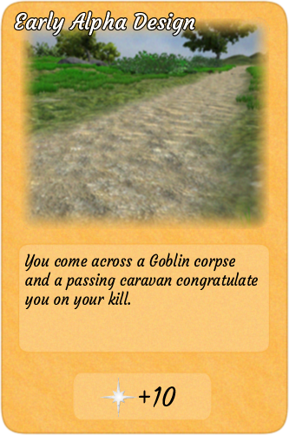

There are some cards that will give the player two choices which they must pick from. Not all choices are straight forward though as one may decrease fame but could also skip your next turn whereas the other choice only increases your fame by a little bit. There are tough choices like that but there are also simpler choices as well like whether or not you kick a bunny. We all know what your answer is.

It is possible to receive magic spells from cards which you can use to interfere with your fellow players from changing the number of dice they roll to increasing or decreasing their attack power in battle. Cards are not just limited to affecting the player as there are some that can affect the world by spawning monsters or affecting the next player to enter a village.

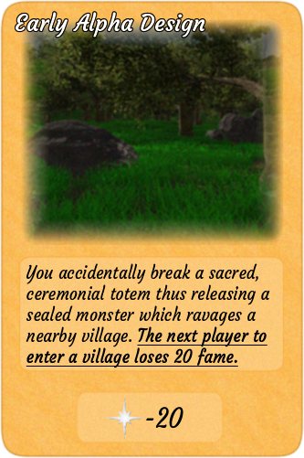

Cards are balanced differently depending on the area tile the player lands on. If you’re already beaten up and near death then the field area is where you want to be whereas for thrill seekers who want high risk, high reward then the mountains are your best bet.

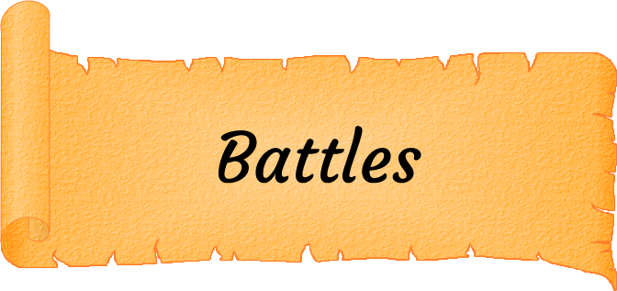

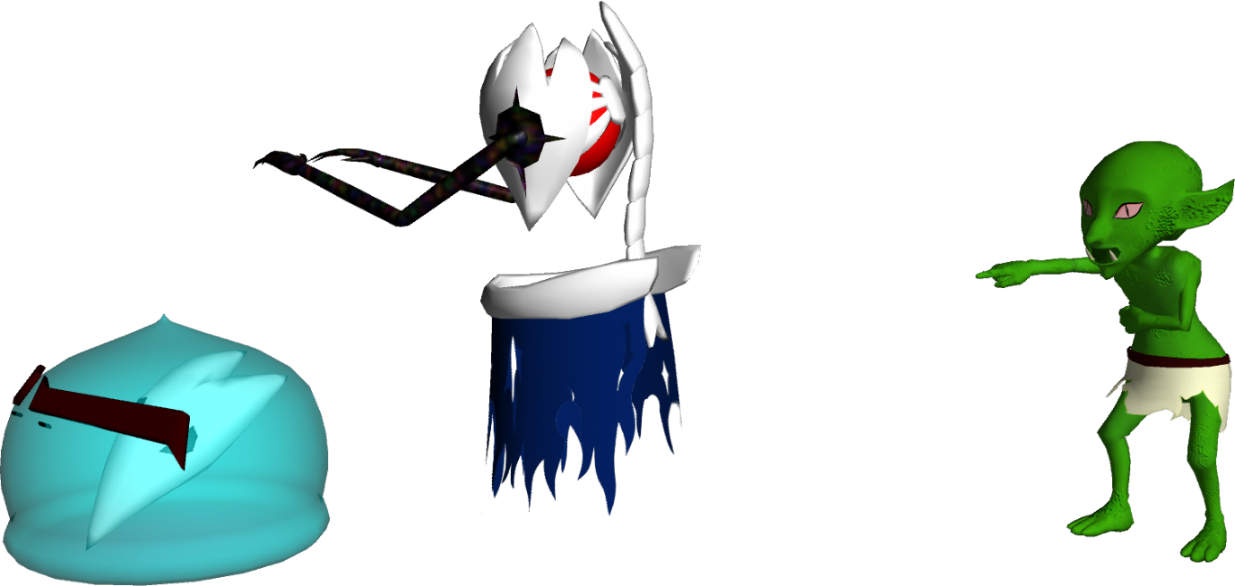

Another way of losing fame is to fight monsters. A battle is initiated when the player lands on a monster tile or passes a tile with a monster on it. Battles are fought by having both parties roll the dice with the roll being added to the party’s current strength attribute and the party with the higher attack power winning. The hero’s strength is derived from the weapon they currently wield.

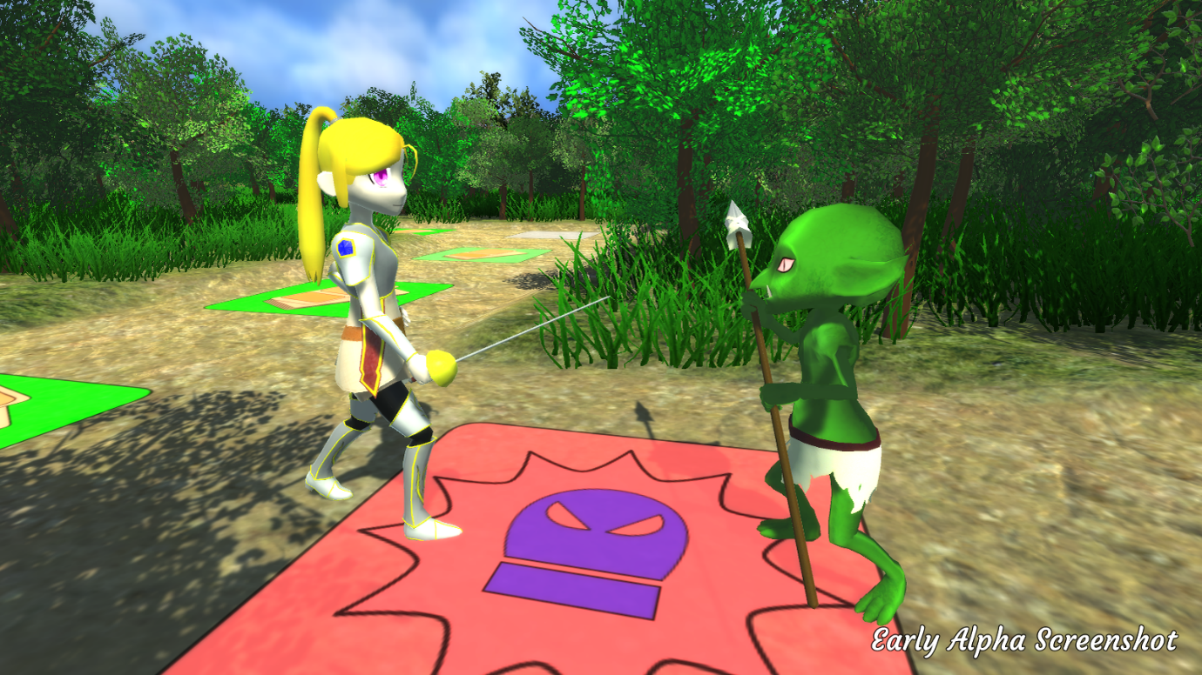

The party which has the highest attack power after calculations will be the one who attacks with the other taking the difference in damage. Just like in most cases winning a blow against a monster will grant you a little bit of fame whereas vanquishing it will get you a decent amount dependant on how strong the monster was. This is not what you want though. You want to lose the roll and have the monster attack you thus dropping your fame. The weaker the monster, the more fame you lose because who’s gonna be surprised if a dragon hurts a hero compared to a slime. Losing all your health to a monster will grant a higher fame loss but it will cause you to miss your next 2 turns as you recuperate.

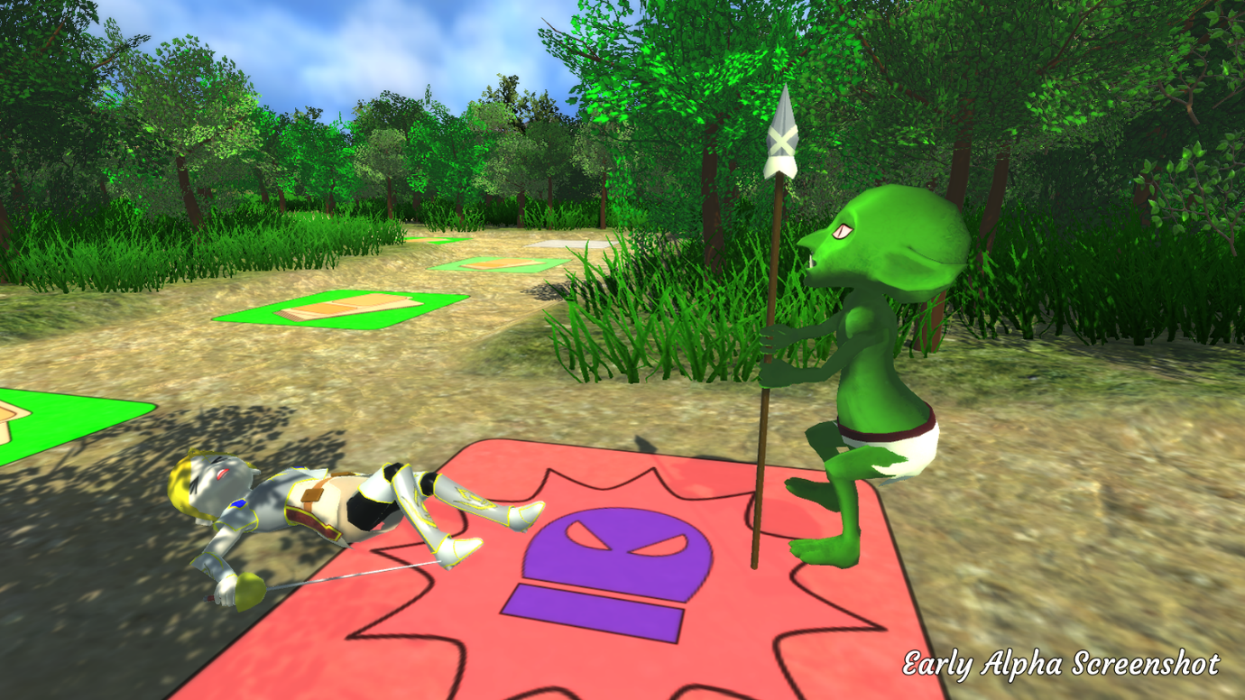

Battles are not just player vs monster events as players can also fight other players by choosing to attack them when passing the same tile. Player vs player battles function the same way as normal battles with the winner gaining fame and the loser losing fame.

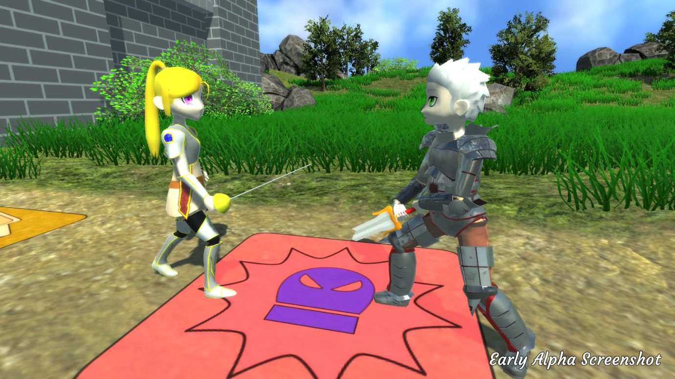

Every battle that takes place is not as simple as you vs the enemy as other heroes can interfere. Other players can cast strengthening or weakening spells on yours or the enemy’s weapon so when you think you’re gonna lose suddenly your rusty blade turns into a sparkly new longsword, raising your attack and ultimately making you win the roll. The same can be said for the enemy; you need to win because you’ve got little health left when another player’s magic changes the slime into mega slime and kills you causing your next two turns to be skipped.

Battles can be risky and you need to figure out when it might be better to win rather than lose while also keeping an eye on other players who might want to interfere. When you can lose a small amount of fame but end up skipping two turns maybe it’s better to beat the monster and take the fame and gold reward.

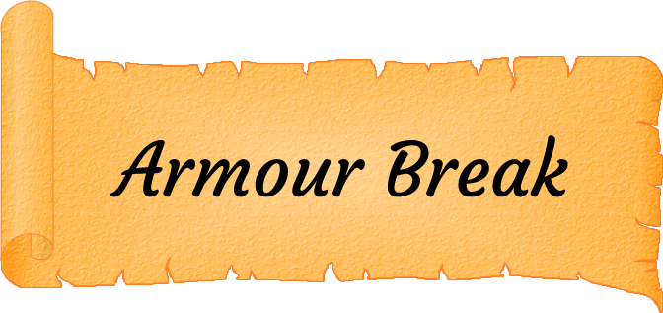

One of the key elements in Hero 2 Zero is that as the game goes on you lose your fame and slowly become a villager again. But who’s ever seen a villager waltzing around while decked out in full armour or a villager buying apples in full arch-wizard robes. More often than not the answer is no one and your hero is no exception. As the player advances on their quest to become a villager they will lose experience and subsequently their high levels as well. As a hero de-levels they will find that they can no longer continue to use parts of their armour which have a minimum level cap. This will result in an armour break which physically sheds the player of their armour.

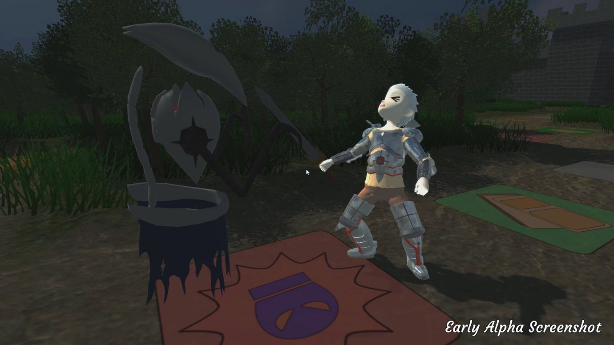

Armour break is important in weakening the hero as their strength will drop thus making it easier for monsters to beat you in battle. Losing more in battle is of course great for losing your fame but in terms of gaining you gold or keeping your health up it is a massive threat which you will need to deal with as you lose more and more armour. Soon those goblins that were scared of you will be laughing at your frailty but at least you’ll fit in with the other villagers.

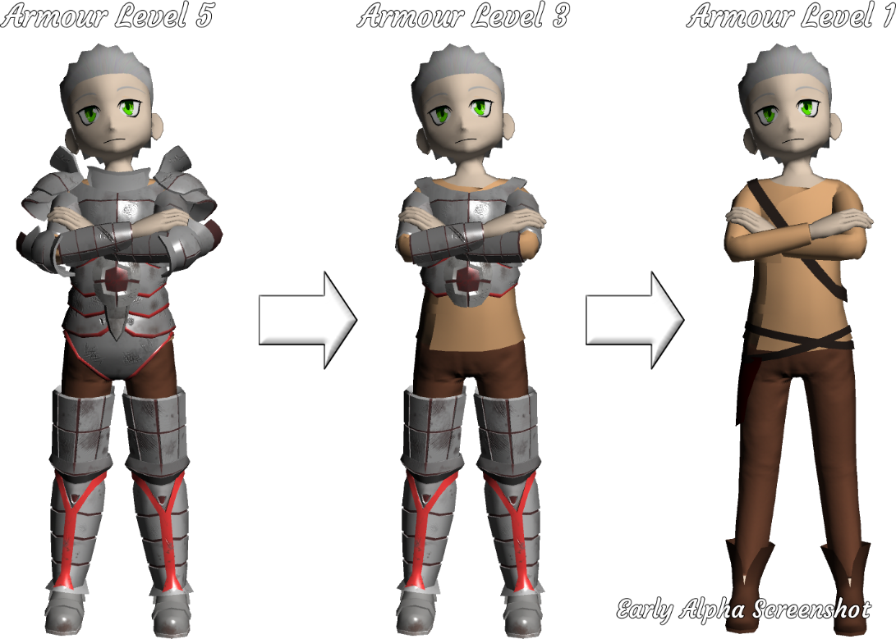

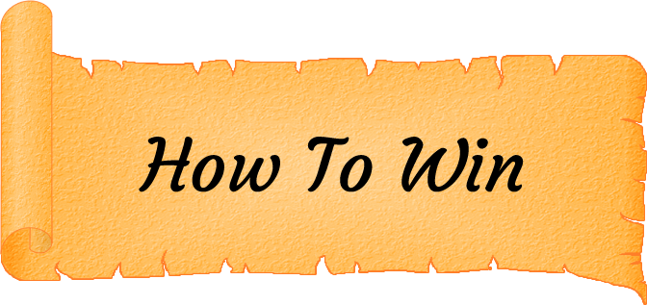

The main goal and condition of winning is to be the first hero to lose all of their fame and become a villager. However there is more than one way to lose your status as a hero.

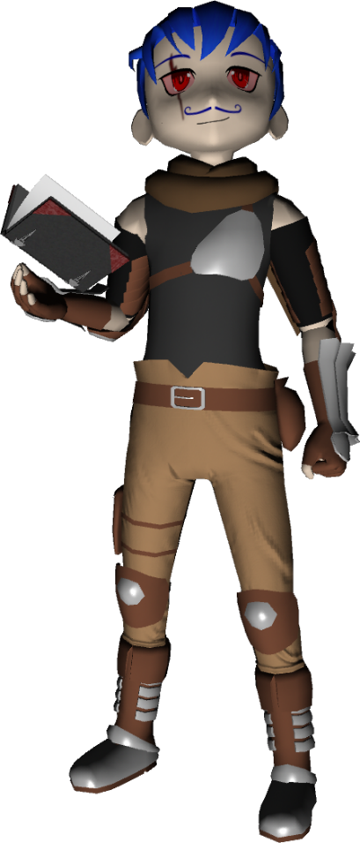

**Villain Route**

Another way to win is to become the complete opposite of what you are now. As a villain your goal won’t be to become a villager again, I mean what out-of-their-mind villain wants to be normal, but instead your goal will become the goal of all villains; to kill the heroes. Not any hero can become a villain though, the ways of a villain must be learned through finding the dark book, the Nomicon. After becoming a villain you will travel the board trying to fight and kill the remaining heroes. Life will probably be more fun as a villain than a villager anyway.

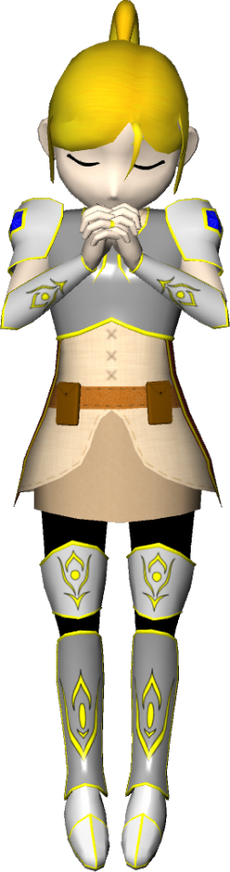

**God Route**

One of the main problems with being a hero is the constant praise and hassle from those that look up to and respect you. But what if there were no people to shower you with praise or no people to crowd you as you walk through a village? Sounds peaceful right? Well if losing enough fame seems impossible then do the opposite and make your goal not to become a villager but to become a God. Build enough fame and the Gods will welcome you among them and then you can use your newly granted powers to remove all life from the realm. You can’t be bothered by supporters when there’s no one to support you after all.

Hero 2 Zero is a turn based board game where each player will adventure around the board with the ultimate goal of dropping their fame and losing their hero status. Players will roll the dice to continue their adventure and choose different directions as the paths start to split; you choose whether or not you enter the forest or climb the mountains.

Players will land on tiles which can do one of a few things. The player could draw an event card based on the tile area, start a battle with a monster, open a chest or just rest plain and simple. Even the best heroes need a rest every now and again.

It is with a combination of these different events that the player will aim to drop their fame before the other players and become the first hero to lose their status.



Hero 2 Zero is currently in development using the Unity 5 engine and is aiming to be made available on Steam for all Windows users.

 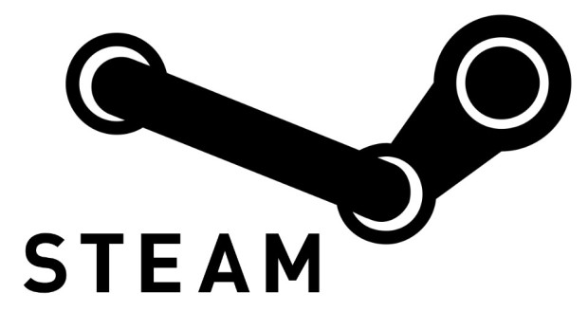 



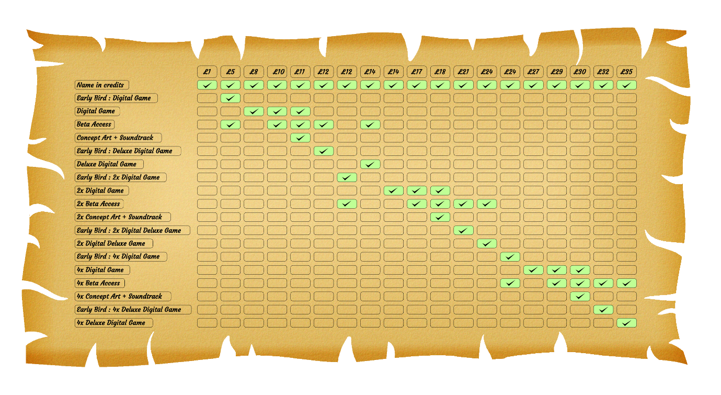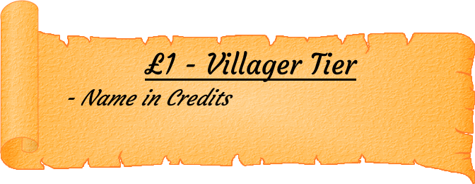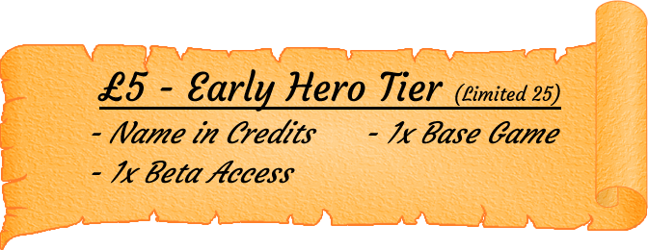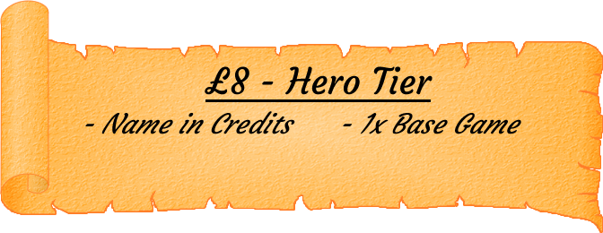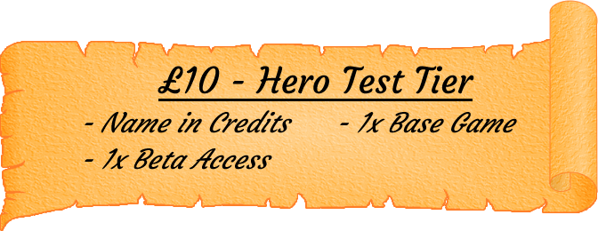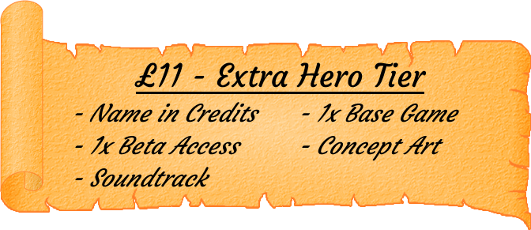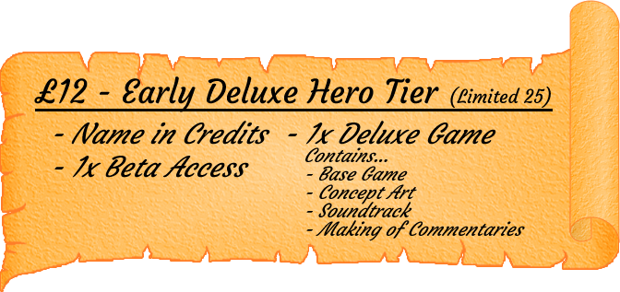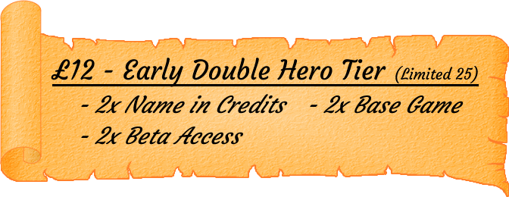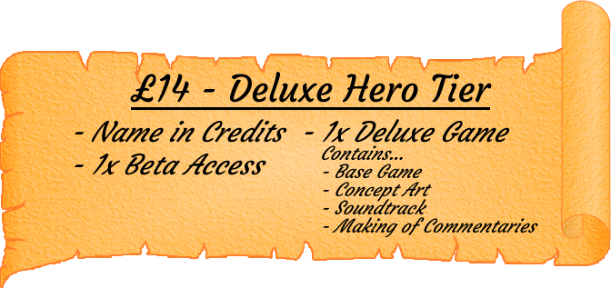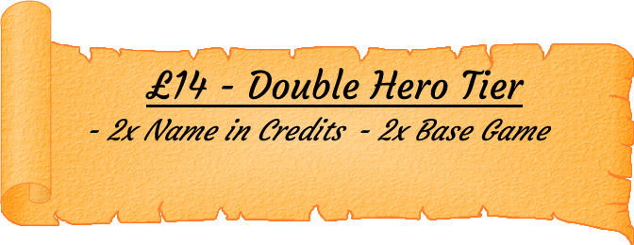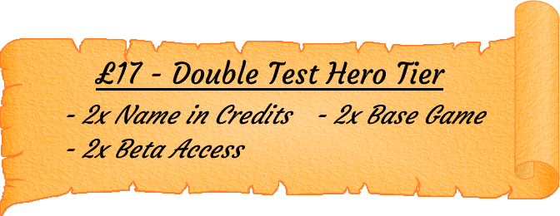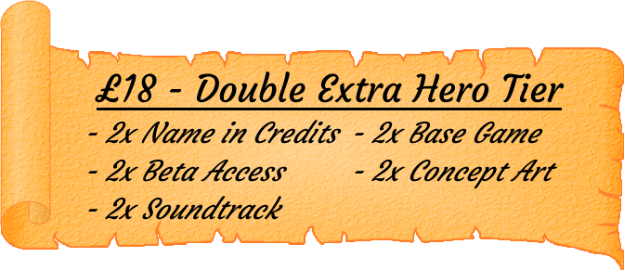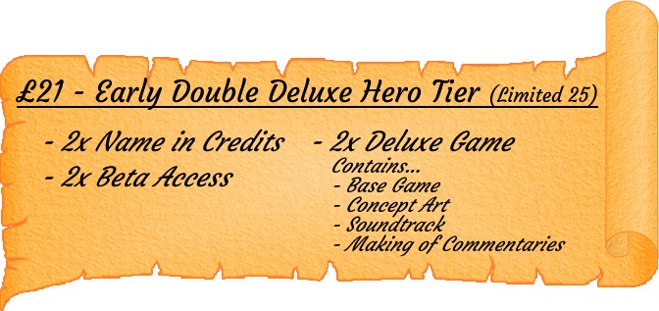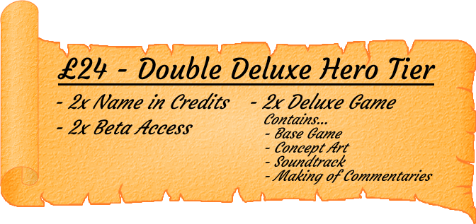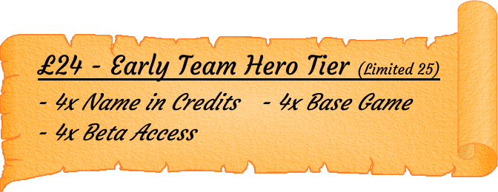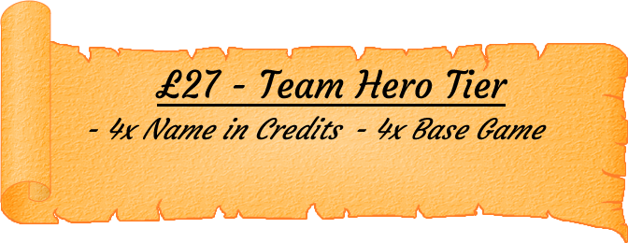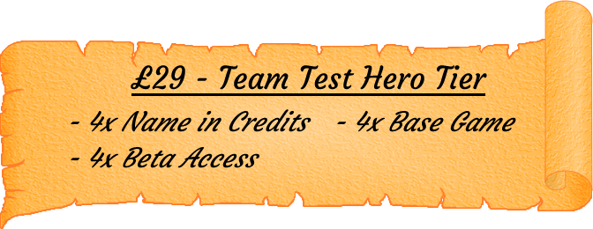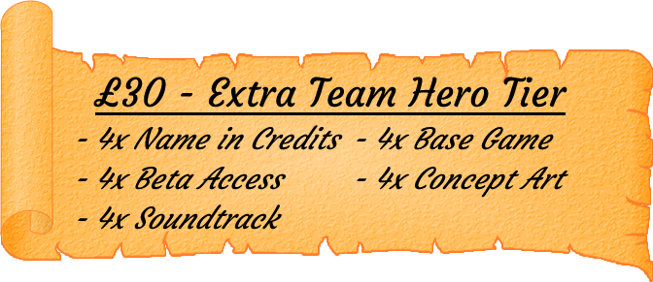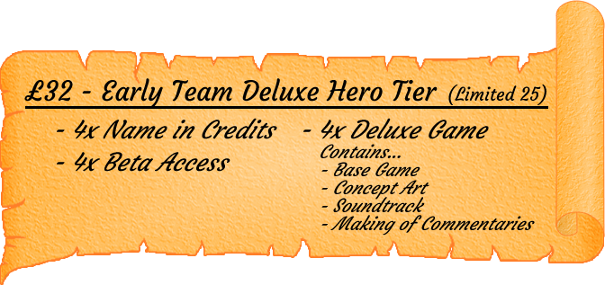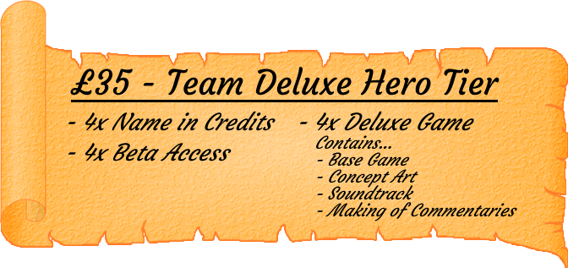

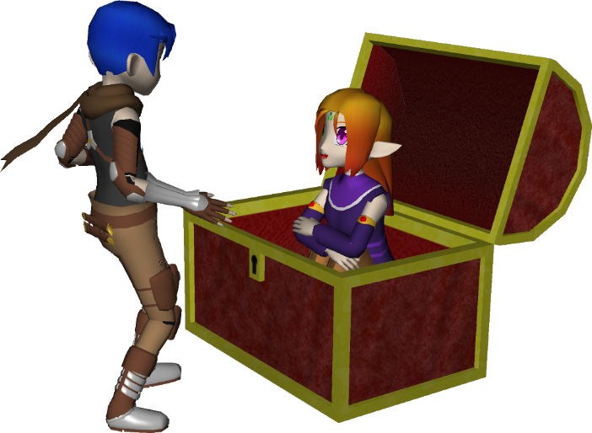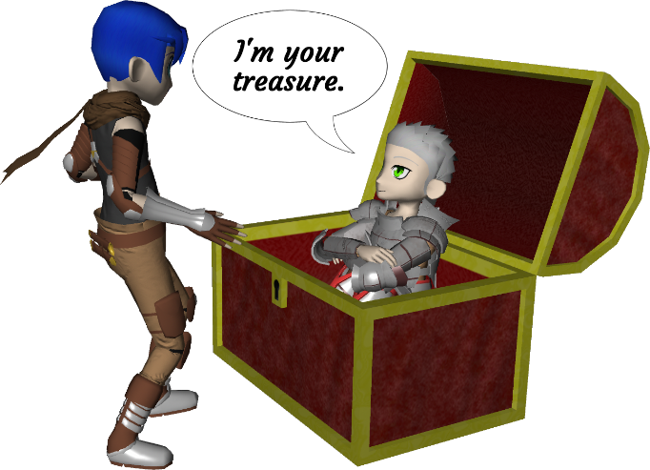

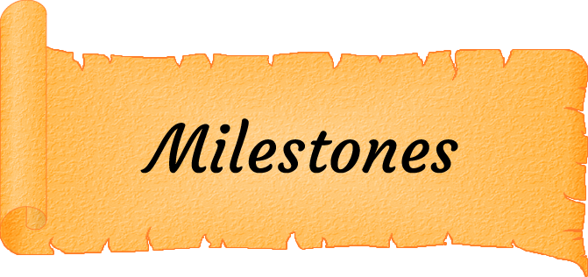

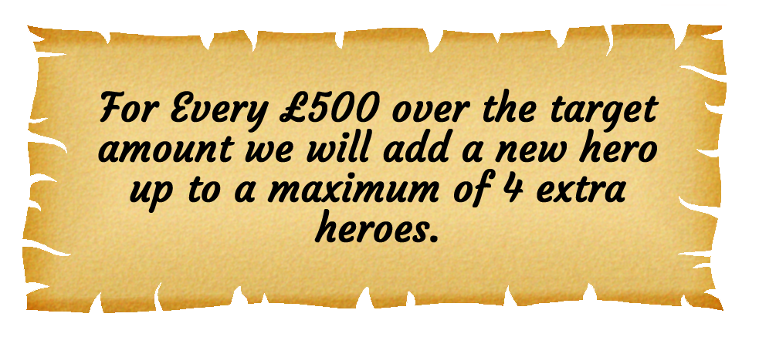

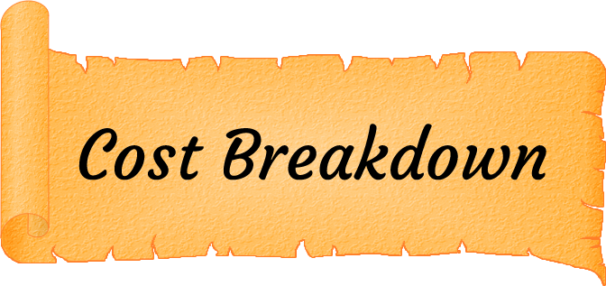

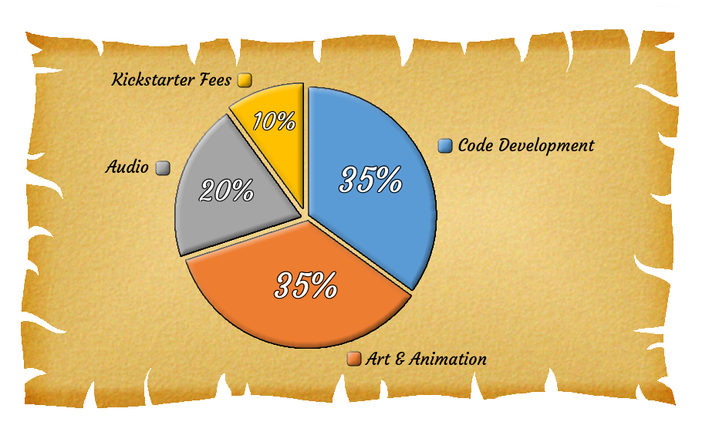

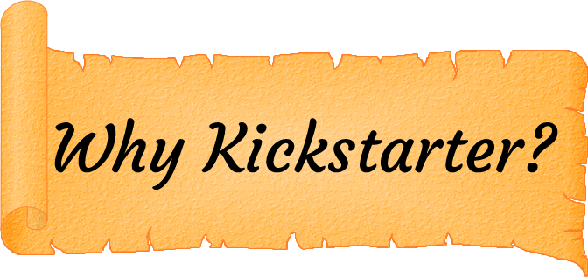

Hero 2 Zero is an independent game developed by Orange Rage Games which consists of only two developers. Up until now, development has been covered by our own savings but proper funding will allow for more content and will help guarantee a greater project come the finish.

We want to give people who believe in this game idea rewards which using Kickstarter we are able to do. We can offer discounted prices for multiple copies of the game to show our gratitude to those that support us.

Kickstarter is also a way of building the basis for a community which we hope will get to enjoy Hero 2 Zero to its fullest. Kickstarter will allow us to keep everyone up to date easily and in a single location that everyone is familiar with. What better place to communicate with the funding community than the place where they give their support.

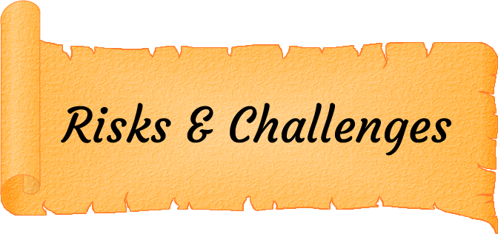

Like with every project there are factors that could threaten to stall development which we can easily mitigate but we can promise there are zero (just like in our game’s name) factors that threaten to stop development completely. (Unless of course both developers die but what are the chances *touch wood*).

We are both devoted in not only completing Hero 2 Zero but also making it an enjoyable experience for everyone that plays or watches it. We want to make this game as great as we can and we don’t plan to relent on that.

Please be assured that should we reach our target goal, Hero 2 Zero WILL get released and we will do everything in our collective power to ensure this statement remains true.

**To all readers that have made it through our campaign, you have our heartfelt thanks for sticking with us and we hope we have piqued your interest in Hero 2 Zero.**